c < log2N < n < n * Log2N < n^2 < n^3 < 2^n < 3^n < n!

<http://www.cppblog.com/85940806/archive/2011/03/12/141672.html>

<http://blog.csdn.net/zolalad/article/details/11848739>

**Question**

Sort the following complexities:

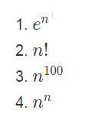

**Hint**

1. Think of what happens when *n* is extremely large.
2. If in doubt, try to break the term into multiple multiplication steps.

**Solution**

